USER GUIDE

*BRAINCELL* *1.0.*

Brain cell *in* *silico*

© University College London, MIT licence

2023

**TABLE** **OF** **CONTENTS**

Table of Contents

INTRODUCTION 4

Key system and software requirements 4

Basic version 4

Full version 4

BrainCell Software: First-Time Installation Guide 5

Unpacking and Running BrainCell (For Users with NEURON and Anaconda Installed): 5

Unpacking and Running BRAINCELL (For Users without NEURON and Anaconda Installed): 5

The strategy of building the model: summary 7

The outlines of experimental data or approximations required to create a realistic brain cell model. 9

GETTING STARTED 9

Installing and running BRAINCELL 9

Setting up and launching 9

File structure in Host computer (under Windows) 10

Preparing BRAINCELL system files 10

Introductory menu 11

Astro/ Base. Setting up and running BRAINCELL: Astrocyte configuration. 11

GENERATING COMPLETE ASTROCYTE MORPHOLOGY 11

Generating/downloading astrocyte stem tree 12

Generating astroglial morphology on the nanoscale 14

The geometry of nanoscopic processes 14

Populating astrocyte tree with nanoscopic processes 14

Tissue-filling properties of astroglial morphology 16

Nano Astro. Download previously created astrocyte morphology. 18

Neuron / Base. Setting up and running BRAINCELL: Neuron module. 19

GENERATING COMPLETE NEURON MORPHOLOGY 19

Nano geometry modification. 21

The arrangement of spines. 21

The spine head and neck geometry. 22

Nano Neuron. Download previously created Neuron morphology. 23

Manage distribution mechanisms. 24

Adjust the spatial distribution of mechanisms. 25

Synapse distribution. 25

Spatial Inhomogeneity of Biophysical Mechanisms Editor. 26

The spatial inhomogeneity specification feature of software. 26

Visualization of Spatial Heterogeneity 27

Adjust the stochastic distribution of mechanisms. 28

Stochasticity Editor 28

Manager of synapses. 30

Synaptic structure. 32

Export cell model. 34

Structure of export file. 35

Simulation modes: Users can choose from a variety of simulation modes to simulate 36

# INTRODUCTION

Welcome to the user manual for **BRAINCELL**!

**BRAINCELL** is a simulation tool designed to evaluate the multi-scale morphology of astroglia and neurons and create realistic multi-compartmental biophysical models of brain cells. With **BRAINCELL**, you can explore these models using the NEURON/Python computational environment, which allows you to incorporate and test a wide range of biophysical, cellular mechanisms. The primary goal of using **BRAINCELL** is to assist with the mechanistic interpretation of experimental observations in brain cells.

This manual will guide you through the features and functionality of **BRAINCELL**, enabling you to use this powerful tool to enhance your understanding of brain cell behaviour.

## Key system and software requirements

The current version of **BRAINCELL** can be downloaded directly from

<https://github.com/LeonidSavtchenko/BrainCellNew>

The present User Manual is to be regularly updated. Its current version can be downloaded from the exact location.

## Basic version

Running **BRAINCELL** without full-scale simulations on cluster requires:

Host computer must have

1. PYTHON (3.2 version or later <https://www.python.org/downloads/>

2. NEURON (7.2 or later, [https://neuron.yale.edu/neuron/download)](https://neuron.yale.edu/neuron/download) installed under Windows 7-12.

## Full version

Running **BRAINCELL** full-scale simulations on cluster requires:

Host computer must have

1. PYTHON (3.2 version or later <https://www.python.org/downloads/>
2. NEURON (7.2 or later, [https://neuron.yale.edu/neuron/download)](https://neuron.yale.edu/neuron/download) installed under Windows 7-12.

Cluster must have

1. PYTHON (3.2 version or later <https://www.python.org/downloads/>

NEURON (7.2 or later, [https://neuron.yale.edu/neuron/download)](https://neuron.yale.edu/neuron/download) Linux

## BrainCell Software: First-Time Installation Guide

Congratulations on choosing **BRAINCELL**, a powerful software for neural simulations. Follow the step-by-step instructions below to successfully install **BRAINCELL** on your Windows operating system. This guide will assist you in setting up the software and addressing any common installation issues.

Note:

* - Make sure you have administrative privileges on your system.
* - The following steps assume you have a reliable internet connection.

## Unpacking and Running BrainCell (For Users with NEURON and Anaconda Installed):

If you do have NEURON and Anaconda installed, please follow these step-by-step instructions to set up **BRAINCELL** correctly:

**1. Unzipping BRAINCELL**

- Download the **BRAINCELL** software package.

- Extract the contents of the downloaded archive to a preferred location (e.g., c:\my\braincell).

- Ensure that all files and folders within the **BRAINCELL** directory are extracted.

**2. Editing init.bat**

- Navigate to the c:\my\braincell directory.

- Locate the file named "init.bat" and open it in a text editor.

- Edit the file to update the path to Neuron. Replace "c:\my\nrn" with the actual path you chose during the Neuron installation.

- Save the changes and close the text editor.

**3. Adjusting File Permissions**

- In Windows 10/11, navigate to the c:\my\braincell directory.

- Right-click on the "init.bat" file and select "Show more options" or "Properties".

- In the Properties window, scroll to the bottom and locate the "Unblock" checkbox.

- Check the "Unblock" box and click "**Apply**".

- Repeat the same process for the "build_mechs.bat" file in the same directory.

(This prevents Windows from blocking the execution of these batch files.)

**4. Running BrainCell**

- Open the c:\my\braincell directory.

- Double-click on the "init.bat" file to execute it.

- This action should launch Neuron and open the **BRAINCELL** window.

- In the **BRAINCELL** window, you can select either "Astrocyte" or "Neuron" as per your requirements.

## Unpacking and Running BRAINCELL (For Users without NEURON and Anaconda Installed but with previous version of Python installed):

If you do not have NEURON and Anaconda installed or are experiencing issues with BrainCell after their installation, please follow these step-by-step instructions to set up NEURON with Anaconda correctly:

**\*\*1. Creating a New Windows User\*\***

- Press the Windows key + R simultaneously to open the "Run" dialog box.

- Type "netplwiz" and click OK to open the User Accounts window.

- Select "Add..." to create a new user account.

- In Advanced mode, choose the option to create a local user account, rather than a Microsoft account.

- Complete the user creation process by following the on-screen instructions.

**Skip the New User Creation:**

If you do not have any existing Python versions installed, Windows Subsystem for Linux (WSL), or Cygwin on your system, you can proceed without creating a new user account.

**\*\*2. Logging in as the New User\*\***

- Log out of your current Windows user account.

- Log in using the newly created user account credentials.

**\*\*3. Installing Anaconda Python\*\***

- Download the Anaconda Python distribution for Windows from the official website.

- Run the installer executable file and follow the installation wizard's instructions.

- Select the default installation options unless you have specific requirements.

- Once the installation is complete, proceed to the next step.

**\*\*4. Installing Neuron\*\***

- Download the Neuron software package.

- During installation, choose a destination folder other than the default location (e.g., c:\my\nrn).

- Follow the installation prompts and accept the default options unless instructed otherwise.

- Once Neuron is installed, proceed to the next step.

**\*\*5. Unzipping BRAINCELL** **\*\***

- Download the **BRAINCELL** software package.

- Extract the contents of the downloaded archive to a preferred location (e.g., c:\my\braincell).

- Ensure that all files and folders within the **BRAINCELL** directory are extracted.

**\*\*6. Editing init.bat\*\***

- Navigate to the c:\my\braincell directory.

- Locate the file named "init.bat" and open it in a text editor.

- Edit the file to update the path to Neuron. Replace "c:\my\nrn" with the actual path you chose during the Neuron installation.

- Save the changes and close the text editor.

**\*\*7. Adjusting File Permissions\*\***

- In Windows 10/11, navigate to the c:\my\braincell directory.

- Right-click on the "init.bat" file and select "Show more options" or "Properties".

- In the Properties window, scroll to the bottom and locate the "**Unblock**" checkbox.

- Check the "Unblock" box and click "**Apply**".

- Repeat the same process for the "build_mechs.bat" file in the same directory.

(This prevents Windows from blocking the execution of these batch files.)

**\*\*8. Running BRAINCELL** **\*\***

- Open the c:\my\braincell directory.

- Double-click on the "init.bat" file to execute it.

- This action should launch Neuron and open the **BRAINCELL** window.

- In the **BRAINCELL** window, you can select either "Astrocyte" or "Neuron" as per your requirements.

## Troubleshooting Steps:

**Initial Installation Attempt:**

Follow the remaining steps of the installation process as outlined in the user manual.

This includes installing Anaconda Python and Neuron, unpacking **BRAINCELL**, and editing the "init.bat" file as instructed. Proceed to adjust file permissions as mentioned in step 7 of the user manual.

**Running BRAINCELL:**

Execute the "init.bat" file from the "c:\my\braincell" directory to launch **BRAINCELL**.

If **BRAINCELL** starts successfully and you can select "Astrocyte" or "Neuron" within the application, you can use the software for neural simulations.

If you encounter any issues during the installation or when running **BRAINCELL** after following the troubleshooting steps, it is advisable to consult the user manual for further guidance. Additionally, our support team is available to assist you in resolving any technical difficulties you may encounter.

## The strategy of building the model: summary

Creating a cell model using **BRAINCELL** can be a complex process, but here are some general instructions to get started:

1. Basic 3D cell morphology. Go to “NeuronMorpho” (<https://neuromorpho.org>) and search for the specific type of brain cell you want to model. Once you have found the cell 3D geometry, download it in the appropriate file format (such as SWC, OBJ or ZIP) in the home directory …\BrainCell\Geometry\ either …\Astrocyte or …\Neuron.
2. Open a BRAINCELL and import the 3D structure file.
3. Adjust the scale of the model to the appropriate size for your needs. This may involve resizing, repositioning, or rotating the model to match your desired dimensions.
4. Once you have created a basic 3D model of the brain cell, you can start adding nanostructures to the model using either an experiment or computer simulation.
5. If you want to add nanostructures to astrocyte model using an experiment, you will need to use specialized software Astro in MATLAB to manipulate at the nanoscale level.

<https://github.com/LeonidSavtchenko/Astro>

1. Alternatively, you can use computer simulations to add nanostructures to the 3D cell. These simulations can help you to understand how the nanostructures interact with the brain cell and how they affect its function.
2. Once you have added the nanostructures to the model, you can use the 3D modeling software to visualize the changes and understand how they affect the overall structure and function of the brain cell.
3. Finally, you can refine and optimize the model as necessary to achieve your desired level of accuracy and detail.
4. Overall, creating a model of a brain cell using **BRAINCELL** is a complex process that requires both specialized software and expertise in both 3D modelling and nanoscale science. By following these instructions and utilising the appropriate tools and techniques, however, you can create a highly accurate and detailed brain cell model that can be used for a wide range of scientific and educational purposes.

5

# The outlines of experimental data or approximations required to create a realistic brain cell model.

Here are the details:

1. It is preferable to have a 3D reconstructed tree of main cell processes that can be imported from ***https://neuromorpho.org*** in any format. Alternatively, an artificially generated cell arbour can be used, with the branching pattern and branch diameters representing the average (typical) cell from the population of interest.
2. Astrocyte nanostructures are essential, and a sample (20-50) of nanoscopic astroglial processes reconstructed using 3D (serial-section) EM is necessary. The sample should have rendered surface coordinates and will be used to obtain statistical properties of the ultrathin processes to be generated in the model.
3. Neuron nanostructures are also needed, and "BRAINCELL" can automatically generate synaptic spines with different distribution densities, geometries, and contacts with synapses. Synapses can be located both on the spines and directly on the dendrites. The user can select all parameters and control the spines’ geometry complexity.
4. The average tissue volume fraction occupied by astroglia and neurons, as distributed radially from the soma to the cell edges, is also required. This data set can be obtained from two-photon excitation measurements in situ (or from published data).
5. It is necessary to have the mean membrane surface density and surface-to-volume fraction values, which can be obtained from 3D reconstructions of nanoscopic processes.
6. The characteristic I-V curve for the cell of interest, obtained through somatic patch-clamp with square-pulse current injections, is essential. Other available functional data, such as electrical responses to neurotransmitter uncaging or changes in extracellular ion and intracellular calcium wave speed, are optional but helpful.

# GETTING STARTED

## Installing and running BRAINCELL

### Setting up and launching

The latest installation version can be downloaded from

[(https://github.com/LeonidSavtchenko/BrainCellNew)](https://github.com/LeonidSavtchenko/BrainCellNew).

On the website’s front page (Fig.1a), to download BrainCellNew, press the green key **'Clone** **or** **download'** and save Download.Zip at any place on your computer. Then the archive must be opened and its content saved on the Host computer (Windows/macOS), keeping the folder structure as described (Fig. 1b).

To start with **BRAINCELL**, the Host computer must have NEURON (7.0 or later) and Python 3.* installed.



A

B

**Figure 1. Screenshot of the BRAINCELL download GitHub page (a) and folder structure of BRAINCELL 1.0 on the Host computer (b).**

## File structure in Host computer (under Windows)

This section explains the initial steps to launch and run the NEURON environment, adapted for brain cell modelling, on the Host computer under Windows.

### Preparing BRAINCELL system files

1. Set the path to NEURON on the Host computer using the batch file ***INIT.bat***; by default, it is set as *NEURON_HOME_WIN="C:\nrn\bin\neuron.exe."*

2. Execute the ***init. hoc*** file located in the host computer directory …*\init. hoc*' or use the ‘NEURON simulations’ button from the start menu panel (Fig. 2).

3. Activate  ***build_mechs.bat*** to trigger the NEURON *.mod file compilation automatically.



**Figure** **2. Introductory** **menu.**

Introductory menu: Simulation Cell Configuration

The simulation interface's menu lets you choose between two types of cells: "**Astrocyte**" and "**Neuron**." Each cell type has two configuration options: "**Base**" or "**Nano**."

1. Users can create and alter cells with variable 3D and nano shapes by selecting the "**Base**" configuration option.
2. Users can upload a previously created cell with nanostructures by selecting "**Nano**" from the drop-down menu. It is critical to note that the shape of the loaded cell cannot be changed. Users who do not want to generate a new cell for each simulation run can utilise this option to save time.

**Select one option for more information.**

1. **Astro / Base****.**
2. **Astro / Nano****.**
3. **Neuron / Base****.**
4. **Neuron / Nano****.**

# Astro/ Base. Setting up and running BRAINCELL: Astrocyte configuration.

## GENERATING COMPLETE ASTROCYTE MORPHOLOGY



**Figure 3.** **Control** **windows** **are** **initiated** **by** **launching** **NEURON** **in** the **ASTRO** **environment,** **as** **detailed** **in** **the text. The file init.hoc opens three windows: System window (cmd.exe) (a), a window panel to define the gross astrocyte geometry (stem tree,b), and a menu panel to set the density for higher orders of nanoscopic processes ('Leaf number' c) and number of nanostructures per dendrites (‘Max number of stalks’, C).**

## Generating/downloading astrocyte stem tree

To design a new astrocyte model, the user has to define the basic structure of a dendritic tree using three different options:

**Option** **1**: Click on "Select Library Stem Tree".

Choose to import 3D files in general zip format from the database http://neuromorpho.com. You can upload as many files as you like, but for convenience, placing them in the directory,.../Geometry/Astrocyte/New Style is recommended.



**Figure 4. Importing 3D Cell Structure. A) The web page of NeuroMorpho displays the 3D shape of a cell. B) Operational BRAINCELL panels providing options to select astroglia morphology.**

Alternatively, select a file from the in-house directory …\BrainCell\Geometry\ in SCW or HOC format.

To view a 3D structure of a file, please follow these steps:

* Select the desired file that contains a 3D structure.
* You will be directed to a new window to view the 3D geometry of the selected file.
* If you like the structure, click the "Use this" button to proceed to the next step.
* If you do not like the structure, you can select another one by clicking the "Import another" button.
* Once you have chosen the desired 3D structure, you can proceed to the next option by clicking the appropriate “Use this” button.
* OriginalDendrite sets the number of branches (dendrites in NEURON terminology) on the stem tree. The database ***NeuroMorpho.org*** can be used as a guide to the ASTRO-compatible file format. A window panel is activated upon selection, displaying the selected stem tree (**Fig. 5b**).

If you press "**Use this**" but change your mind later, don't worry; making a new selection is simple. Press the "Select Library Stem Tree" button or choose "Select Stem Tree with Endfoot" from the options.

1**. Editing the Endfoot Geometry:**

A popup window will appear if you select the "Select Stem Tree with Endfoot" option. This window allows you to modify the geometry of the endfoot (refer to Fig. 5B), providing a menu to set the morphology of the main and the secondary endfoot branches and the local biophysical mechanisms.

2. **'Select** **reconstructed** **stem** **tree’** loads the 3D-reconstructed stem tree file. An example in ***RealAstrocyteSkeleton1.hoc*** (the directory …*/Geometry*) shows the reconstructed stem tree of the CA1 astrocyte using the Vaa3D software (Allen Institute, available from [http://www.alleninstitute.org/what-we-do/brain-science/research/products-tools/vaa3d/)](http://www.alleninstitute.org/what-we-do/brain-science/research/products-tools/vaa3d/). This option also prompts an additional window panel (Fig. 17d), providing a setting for geometrical scaling and the centring of the astrocyte structure at the coordinate origin (to facilitate the positioning of selected cell compartments). The corresponding menu buttons thus include '**X-Y** **scale** **(pixel/μm)**', '**Z** **scale** **(pixel** **μm)**', and '**X-Y** s**hift** **(μm)**'. This window will disappear after any parameter change.

**Note:** Regardless of the case, a popup window directs you to the directory where the 3D file should be located. Make sure you have downloaded the required geometry file in advance using Neuromorphic.

3. **Adding Nano Geometry to the Astrocytic Tree:**

Once you have finalised the 3D geometry of the astrocyte, you have the option to incorporate nano geometry into the structure. To achieve this, you can use a file containing nano geometry that you have prepared using the Astro package. Select the "Select Diameter Distribution for Nano Geometry" option or press the "Start Astro" key. The BrainCell module will generate the astrocyte geometry randomly while ensuring it adheres to primary physiological constraints.

We recommend using the "Start Astro" key when initially acquainting yourself with the software program. This will help you familiarise yourself with its functionalities and capabilities.



**Figure 5.** **Operational window panels for the creation of gross astroglial morphology. A) Host computer directory displaying hoc-files with 3D shapes. B) Panel for generating EndFood for astrocytes. C) Panel for exporting the 3D structure of the cell. D) Panel for transforming 3D shape. These panels are essential for manipulating and generating astroglial morphology in three dimensions.**

**NOTE:** The user must upload the cell stem tree geometry before initiating any further design of the model

## Generating astroglial morphology on the nanoscale

### The geometry of nanoscopic processes

Once the stem tree has been downloaded, the next stage is the nanostructure of the astrocyte. The user has two options on the popup window (see below), highlighted in yellow.



**Option** **1:** To download the default nanostructure prepared in advance. Pressing the button **'Diameter** **distribution** **for** **nano-geometry'** prompts the user to download a file with the statistics of process diameters produced by the '**Nano** **(Geometry)'** module from the sampled 3D-reconstructed astroglial processes (see above). By default, this option downloads the file ***testshape.dat_radii_dist.txt*** (characterising astroglial processes in CA1 *stratum* *radiatum*). After that, the user presses the '**Start** **Astro’** button.

**Option** **2:** To press the '**Start** **Astro’** button, in which case ASTRO generates nanoscopic processes automatically using the built-in tools.

In both cases, the user can repeatedly adjust key morphometric features of the generated nanostructures. See further details in the chapter **Simulating** **Astrocyte** **Physiology**.

### Populating astrocyte tree with nanoscopic processes

The '**Start** **Astro’** button prompts the main window panel '**Repertoire** **of** **computation**', which is critical to modelling complete astrocyte morphology, as described in the sections below.

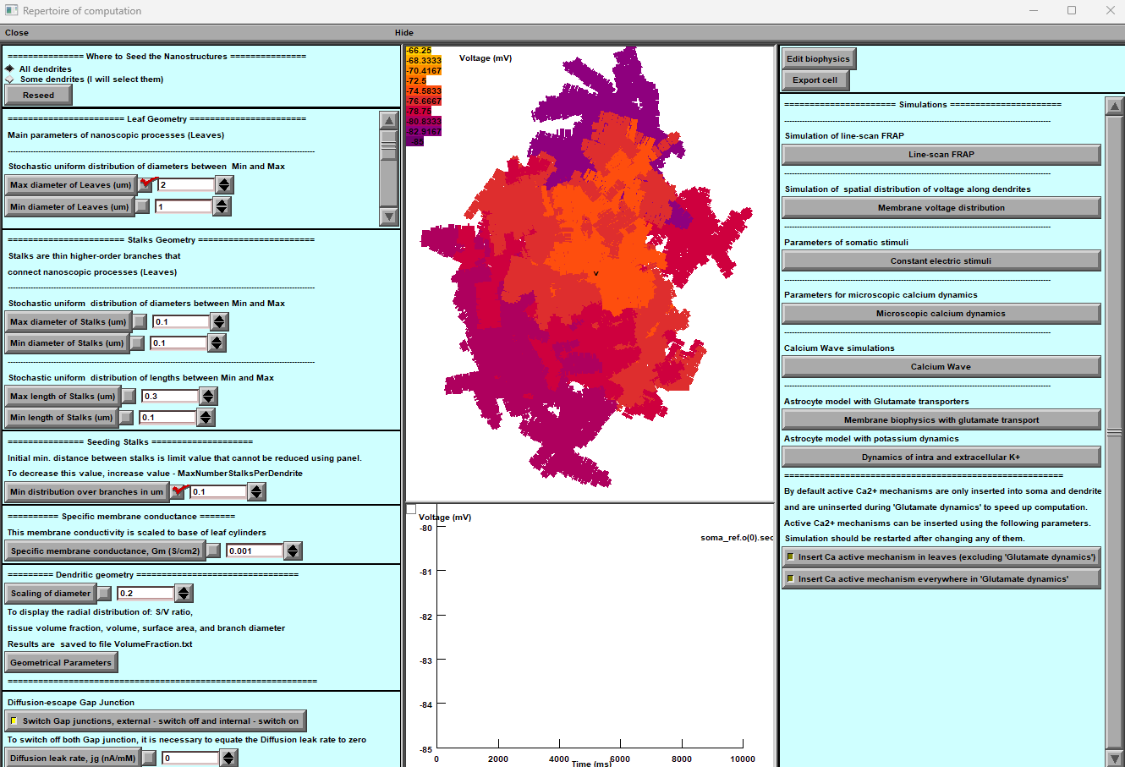

**Figure 6. The main window of astrocyte. a Control panel provides detailed astrocyte geometry settings, including a gap junction feature (bottom). b, Simulated variable mapped onto astrocyte morphology (top; membrane voltage shown), with selected digital output plot (bottom). c, Computational scenarios with parameter setting.**

One of the essential features for managing nano geometry in the software is located in the upper left corner of the main window (Fig.6 A). This option enables the creation of nano geometry exclusively in a specific location within the dendritic tree. To utilise this feature, follow the steps outlined below:

* Switching from "**All dendrites**" to "**Some dendrites**" option: By toggling this option, you can restrict the nano geometry creation to specific dendrites.
* Initiating the "**Reseed**" process: Press the designated "**Reseed**" key to activate this process. This action will prompt an additional window to appear, providing further customisation options for the placement of the nano geometry.
* Specifying the desired location: In the newly opened window, you can specify where you want to add the nano geometry. This level of control allows you to target specific areas within the dendritic tree.
* Selecting dendrites: Select the desired dendrites in the window. This step involves identifying the dendrites where you intend to generate an astrocyte with localised nanostructures.
* Finalizing the process: After selecting the desired dendrites, press the "Done" key to generate the astrocyte with the specified nanostructures localised to the chosen dendrites.

NOTE: This option will increase computational requirements, mainly when focusing on very localised processes within the astrocyte. It is beneficial for users who are interested in studying fine-grained details within the astrocyte's local environment.

Panel '**Leaf** **Geometry'** (Fig. 6a, top) provides an option to set up the distribution of cylindrical compartments (leaves) of nanoscopic processes as evenly random (with lower and upper limits) when the experimental statistics on 3D reconstructed processes are not available.

NOTE: This section will be ignored when the latter has already been loaded (see previous section).

Panel '**Stalk** **Geometry'** (Fig. 6a, middle) sets upper and lower limits for the uniform distribution of transitional cylinders of nano geometry. These parameters determine how densely the tissue will be filled with nanoscopic astroglial processes.

Panel **'Specific** **membrane** **conductance'** sets this value at the button '**Gm** **(mS/cm2**)', which considers all exposed surfaces of the cylindrical compartments. The resting potential of the current is -85 mV. This parameter is defined on the built-in NEURON panel “Distributed mechanism”.

Panel **'Dendritic** **Geometry'** (Fig. 6a, bottom) currently includes **'Branch** **diameter** **scaling',** which sets the scaling coefficient for the stem tree branch diameters as a function of distance from the soma, according to the average experimental trend. The empirically established formula for the branch diameter *d* is *d*~(*S*(*r+1*))-1/2 where **'scalingDiam'** value S and *r* is the distance to the soma.

NOTE: This panel has to be ignored if a 3D-reconstructed stem tree has been uploaded.

Panel **'Gap** **junctions'** is explained in the **Gap** **Junctions** section below (chapter **Simulating** **Astroglial** **Function**).

### Tissue-filling properties of astroglial morphology

The tissue volume-filling properties and the surface-to-volume ratios of the nanoscopic processes will be determined by the shapes and the effective density of simulated nanoscopic processes, as described in the previous section. Tissue volume filling and other geometry features of the model can be monitored by pressing the **'Geometrical** **parameters'** key (Fig. 6): this opens several window panels displaying various parameters of the modelled cell geometry (Fig. 7). The displayed data are automatically saved to the file ***…\neuronSims\Text*** ***results\VolumFraction.txt***.



**Figure** **7.** **Window** **panels** **provide a readout of the volumetric characteristics for modelled astroglia (launched by the 'Geometrical** **parameters'** **button).**

From the top left: surface-to-volume ratio distribution, tissue volume fraction, total cell volume (cumulative value with the distance from the soma), total cell surface area, and diameters of primary processes.

The morphometric characteristics of the simulated astrocyte (Fig. 7) are to be compared with the corresponding empirical data obtained using 3D EM reconstructions and two-photon excitation imaging data for the astroglia of interest. The user is free to evaluate the mismatch and adjust the density of nanoscopic processes (using '**Stalk** **Geometry'** and '**Dendritic** **Geometry'** options where relevant; Fig. 6) correspondingly until an acceptable match is produced. The windows depicting critical geometrical parameters (Fig. 7) can be viewed anytime during modelling.

At the end of this stage, the modelled astroglial morphology is complete (see 'FRAP experiments' below for further subtle morphological adjustments). The user can begin to simulate various astroglia functions while also implementing various membrane and intracellular biophysical mechanisms, as briefly explained in the sections below.

# Nano Astro. Download previously created astrocyte morphology.



**Figure 8**. **Operational** **window** **panels** **uploaded pre-existing structure astroglial** **morphology. A) Download panel for previously prepared 3D astrocyte structure, B) Roadmap panel to select between new or pre-existing structure, C) Schematic illustration of full 3D and nanostructure of pre-existing astrocyte.**

Combination "Astro + Nano" (Fig.8 B) to pop up a panel to download the pre-existing astrocyte morphology. Once the panel appears, you can proceed with the following steps and open NEURON Basic Panel: The NEURON basic panel will allow you to locate the previously prepared astrocyte with Nanostructure.

Select the astrocyte with Nano structure to proceed with simulation and management of biophysical mechanisms. This will take you to a new option for simulation and management.

At this stage, you can simulate and manage the biophysical mechanisms of the selected astrocyte with Nanostructure. Please note that you cannot change the geometry at this stage.

# Neuron / Base. Setting up and running BRAINCELL: Neuron module.

## GENERATING COMPLETE NEURON MORPHOLOGY

In this section, we will describe the **BRAINCELL** part specifically designed for constructing a 3D model of a neuron. Please note that this part is different from the one used for astrocytes.

When you load a 3D neuron, you will be presented with two windows that will allow you to determine the critical features of the neuron's structure. The first window will enable you to set the maximum number of spines on the dendrite (Fig.9A and B). This function is critical and can be changed in the future, along with the geometry of the spines.

The second window (Fig.9C)is much larger and will allow you to determine the neuron's soma, dendrites, and axon. If the axon is not defined initially, the program will generate a basic axon that you can modify later. Please note that distinct components of a neuron cannot share the same name. If this occurs, the software will immediately give you an error message.

To create a 3D neuron, select the desired configuration and click OK. The program will then render the form you have selected, and you can use it for other neuron model assembly or try another form from the database.



**Figure 9. Import, Selection, and Final Shape of the 3D Structure of a Nerve Cell. A) Spine Density Control Panel: This panel enables adjustment of the maximum number of spines per dendrite. It should be noted that larger dendrites generally exhibit lower spine density. In future iterations, users will have the ability to modify spine density.**

**B) Cell Shape Selection Panel: This panel provides options to select the desired final shape of the cell.**

**C) Cell Structure Definition Panel: This crucial panel empowers users to define the cell's soma, dendrites, and axon. Future updates allow users to customise the geometry vocabulary and organise dendrites into subgroups.**

Figure 9 illustrates the process of importing, selecting and shaping a 3D structure of a nerve cell. Panels demonstrate:

* the import process, where the user can identify the soma, dendrite or axon and determine the maximum number of spines on the longest dendrite,
* displays the selected structure, enabling the user to accept or import another structure for viewing.

This figure provides a visual representation of the crucial steps involved in the process of constructing a 3D model of a nerve cell. If the user decides to try another neuron morphology, the procedure must be repeated, as previously described. If the user decides to stop at this one, a new window will appear by pressing the "**Use this one**" button.

Using **BrainCell**, users can customise the geometry and morphology of neurons by selecting the desired parameters and pressing the "**use this Neuron**" button. This will open the main window, which provides access to various functions that can improve the cell's geometry, visualise any changes made, and begin incorporating various biophysical mechanisms with different spatial distributions and stochastic properties.

In the main window (Fig.10), users can easily modify the geometry of the neuron and observe the results in real time. Additionally, users can experiment with different biophysical mechanisms and their corresponding spatial distributions and stochastic properties. This allows a more comprehensive understanding of the neuron's behaviour and function.

Overall, our software provides users with a powerful tool to customise and analyze neurons' geometry and biophysical properties, all within an easy-to-use interface.

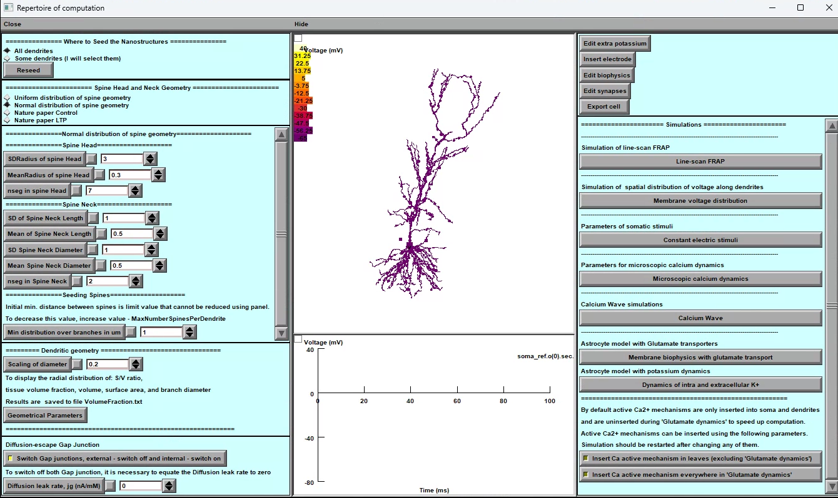

**Figure 10. Main windows for neuron simulation. The tool’s main window provides several options to simulate neuron behaviour effectively.**

Below are the key features of the main window:

1. **Nano geometry modification**: Users can add and modify spines' nano geometry to study the impact of structural changes on neuron behaviour.
2. **Biophysical mechanisms addition**: The tool enables users to add and change various biophysical mechanisms to neurons to investigate their impact on neuron behaviour.
3. **Synapse distribution**: The tool facilitates the addition and distribution of different types of synapses on the dendritic tree, enabling the study of the neuron's connectivity and behaviour.
4. **Simulation modes**: Users can choose from various simulation modes to simulate the neuron's behaviour accurately. The simulation modes include voltage clamp, current clamp, and dynamic clamp.

The neuron simulation tool's main window provides the necessary features to effectively simulate and analyse neuron behaviour.

## Nano geometry modification.

Users can add and modify spines' nano geometry to study the impact of structural changes on neuron behaviour.

### The arrangement of spines.



**Figure 11. A panel of the dendritic tree's synaptic dispersion. With this feature, users can specifically access the dendrites where they want to place spines. They have two options - select individual segments of the structure or choose the entire branch.**

The "Where to Seed the Nanostructures" tab (Fig. 11) allows the user to distribute the spines on specific dendrites and across the cell.

The user can distribute the spines on individual dendrites by clicking (using the mouse) on a specific dendrite (+Shift for several dendrites) on a panel presenting the 3D structure of the neuron.

If you are happy with your chosen distribution, click the "Done" button. You may, of course, adjust the distribution of synapses at any time.

### The spine head and neck geometry.



**Figure 12. A panel of spine geometry modification.**

This part explains how to use the tool to analyse the geometry distribution of dendritic spines (Fig.12). The panel provides two distribution options: regular and uniform, allowing the user to set numerical parameters for each distribution via a window upon selection. The tool also considers the minimum distance between synapses in a dendritic tree as an essential parameter for synapse distribution.

**Selecting a Distribution:**

To use the tool, the user must first select a distribution type. There are two options available: regular and uniform. The user can select a distribution type by clicking on the respective button on the panel (Fig.12). Once the user has selected a distribution type, they can set numerical parameters for each distribution via a window that appears upon selection.

**Using Pre-Established Distribution Types:**

The tool provides pre-established distribution types of spine geometry to make it more convenient for the user. These pre-established distribution types have been published in Tønnesen, J., Katona, G., Rózsa, B. et al. Spine neck plasticity regulates the compartmentalization of synapses. Nat Neurosci 17, 678–685 (2014). https://doi.org/10.1038/nn.3682. To use these pre-established distribution types, the user can click on the respective button on the panel. This will provide the user with experiment-measured parameters for the selected distribution type.

**Adjusting Spine Complexity:**

Another crucial factor in determining spines is their spatial complexity (number of segments), which affects calculation speed. The number of segments can be adjusted with a minimum of two and no maximum limit. The user can adjust the complexity parameter using the panel slider.

**Minimum Distance Between Synapses:**

The tool also considers the minimum distance between synapses in a dendritic tree as an essential parameter for synapse distribution. The shorter the distance, the more spines on the tree. However, this parameter is stochastic, meaning that the tool considers the element of chance in its calculations. The user can adjust the minimum distance between synapses using the panel slider.

***In conclusion, this tool allows users to analyze the geometry distribution of dendritic spines. The tool offers two distribution options: regular and uniform, which the user can select. The user can set numerical parameters for each distribution via a window upon selection. The tool also considers the minimum distance between synapses in a dendritic tree as an essential parameter for synapse distribution. Users can adjust the minimum distance between synapses and the complexity parameter to suit their requirements.***

## Nano Neuron. Download previously created Neuron morphology.

The combination "Neuron + Nano" creates a new panel. Once the panel appears, you can proceed with the following steps and open NEURON Basic Panel, which will allow you to locate the previously prepared Neuron with Nanostructure.

To proceed with the simulation and management of biophysical mechanisms, select the neuron with Nanostructure in hoc-file. This will take you to a new option for simulation and management (see Fig.13).

***Please note that you cannot change the geometry at this stage.***



**Figure 13: 3D reconstruction of a neuron with nanostructures. The geometrical shape is currently non-modifiable at this stage.**

## Manage distribution mechanisms.

The tool enables users to add and change various biophysical mechanisms to neurons to investigate their impact on neuron behaviour.

**Upon clicking** the "**Manage the distance of Mechanisms**" button located in the upper right corner (**Figure 10.** **Main Window**), the user shall be presented with two significant panels, as depicted in (**Figure 10**).

Instructions for the software panel Fig.14:

The software panel comprises two windows: the first (A) and the second (B).

Window (B) allows users to insert and remove mechanisms into predefined regions of the brain cell. The "Mechanisms" folder contains all the available mechanisms, and the previously constructed neuron components are displayed in this window. This window has two modes, namely the initial mode that shows the mechanisms present in each neuron segment and the secondary mode, which displays the location of each mechanism within the neuron segment. To use this window, users can select the required mechanisms by ticking the corresponding checkboxes.



A

B

**Figure 14. Panels for Biophysical Mechanisms Management**

**(A) The Manager of Distributed Mechanisms Panel is designed to facilitate the operation of compartments and mechanisms. This panel allows users to work with different mechanisms within specific cell areas easily.**

**(B) The Insert/Remove Mechanisms Panel provides a comprehensive list of available mechanisms for users. Each cell area has its own unique set of mechanisms, and the "Apply" button enables users to add selected mechanisms to the designated area.**

The second window (B) is crucial in performing cell-part operations. This window allows subgroup, merge, or rename different cell parts. Additionally, the second section of the window enables users to interact with the biophysical mechanisms. Within this section, users can access several panels that allow them to manipulate the mechanisms in various ways. These include the ability to insert or remove mechanisms, adjust the spatial distribution of mechanisms, and review mechanisms that display spatial inhomogeneity. Moreover, users can analyse stochastic mechanisms through this window.

### Adjust the spatial distribution of mechanisms.

The central panel (**Figure 15**) adjusts spatial distribution of mechanism across any part of the cell allows the user different options to define the mathematical formula for the spatial distribution.

A

B

C

D



## Synapse distribution.

The tool facilitates the addition and distribution of different types of synapses on the dendritic tree, enabling the study of the neuron's connectivity and behavior.

**Figure 15: Panels for adding spatial properties to biophysical mechanisms in a cell. A) Mechanism Selection Panel: Users can select a biophysical mechanism and choose to modify its spatial. B) Spatial Property Definition Panel: Users can define the spatial properties of the selected parameters or variables. C) Examples Panel: Displays examples of the types of parameters and variables that can be modified for each biophysical mechanism. D) Spatial Model Activation Panel: Users can enable the spatial properties of the selected parameter or variable by pressing the "Define as a function " button.**

The main interface (Fig.15A) is accurately designed to integrate with the various biophysical mechanisms in different parts of the neuron. Each segment of the neuron is conveniently located within its respective window in the main interface, containing all the biophysical mechanisms associated with it.

To make changes to any mechanism, click on it, and a menu will pop up (Fig.15**C**), allowing you to select the desired editing options. This menu includes choices for global variables, state variables, and parameters. For more in-depth information about a selected variable, click on any of these options to access a separate window (Fig.15D).

In the new window, you'll see the current value of the variable if it's spatially homogeneous. If you want to make it spatially inhomogeneous, click the "**Define as a function of distance**" bar. Doing this will open a new window called the Heterogeneity Editor (Fig.15B).

In the **Heterogeneity Editor**, you can define the variable as a function of distance. This allows you to customise the properties of the variable based on the spatial location. Once you've described it, you can save your changes (Apply button) and edit other mechanisms.

### Spatial Inhomogeneity of Biophysical Mechanisms Editor.

This editor (Fig.15B) allows to work with segments of neuron in order to determine the heterogeneity of mechanisms.

The editor's main window is divided into three parts. The upper part of the panel is where you can work with segments of neuron parts. This is a crucial part of the software because heterogeneity is determined not in each physical coordinate of the neuron but in each segment.

For example, if your dendrite has only one segment, no matter how long it is, it will be spatially non-uniform. Therefore, you must increase the number of segments for more detailed spatial heterogeneity. However, it should be noted that the more segments you have, the longer the calculation will take.

### The spatial inhomogeneity specification feature of software.

This feature is designed to allow you to specify the spatial inhomogeneity of a selected mechanism in your simulation. To use this feature, navigate to the central part of the window. Here, you will find the panel that offers five different modes for specifying the spatial inhomogeneity of your mechanism. Let's take a look at each of these modes:

**Simple Model**:

This mode offers several options to specify the spatial inhomogeneity of your mechanism. You can choose a constant value for the spatial inhomogeneity or specify a linear, quadratic, or polynomial function with two, three, or more parameters. You can also choose an exponential function for the spatial inhomogeneity.

**Custom Function**:

If you have a specific function in mind that is not covered by the options in the Simple Model mode, you can use the Custom Function mode. Here, you can enter any function you like, as long as it is written in either the neuron language or Python. To set your custom function, simply use the pop-up window.

**Custom Function from File**:

In addition to the Custom Function mode, you can also specify a custom function from a file. This option allows you to define your function in a separate file, written in either Neuron or Python. Once you have created your file, you can specify it in the software and use it to specify the spatial inhomogeneity of your mechanism.

**Table Function**:

If you have experimental data that you would like to use to specify the spatial inhomogeneity of your mechanism, you can use the Table Function mode. This mode allows you to download your data either manually or as a text file and use it to specify the spatial inhomogeneity.

**Special Function**:

Finally, the "Special Function" option displays sections and the distribution of segments within the neuron cell. You have control over the cell model's discretization stage. The discretization is depicted on the cell's spatial graph. The segments are marked differently for better visualisation.

### Visualization of Spatial Heterogeneity

This part provides two different ways to visualize spatial heterogeneity. To access these options, navigate to the lower part of the main panel.

**Option 1**: Heterogeneity as the Distance from the Soma with this option, you can visualize the degree of spatial heterogeneity related to the Distance from the Soma. This visualization can help you identify areas of the neuron that exhibit high or low heterogeneity. To use this option, simply select it from the main panel.

**Option 2**: Spatial Colour map of Inhomogeneity on a cell. This option allows you to visualize spatial heterogeneity using a colour gradient representing the degree of inhomogeneity on the cell. The colours range from cool to warm, with cooler colours indicating lower levels of inhomogeneity and warmer colours indicating higher levels. To use this option, select it from the main panel.

Both of these visualization options can provide valuable insights into the spatial heterogeneity of your neuron. Choose the option that best suits your needs and explore the heterogeneity of your neuron in new and insightful ways.

## Adjust the stochastic distribution of mechanisms.

The main panel (**Figure 16**) to adjust stochastic properties of mechanism across any part of cell allows the user different option to define the mathematical formula for the stochastic distribution

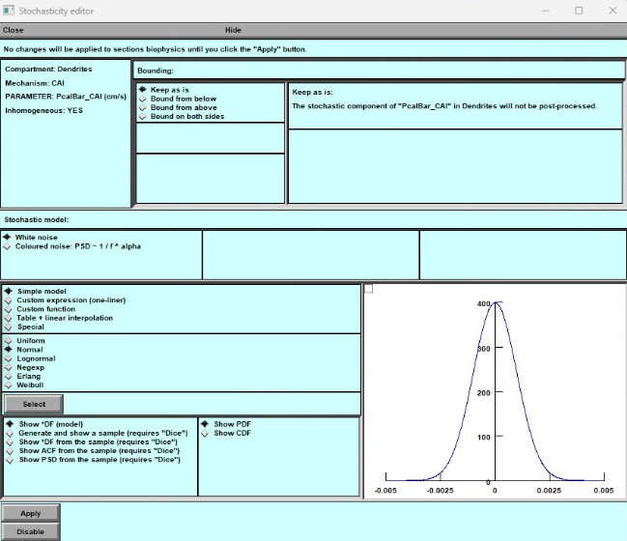

A

B

C

D

**Figure 16: Panels for adding stochastic properties to biophysical mechanisms in a cell. A) Mechanism Selection Panel: Users can select a biophysical mechanism and choose to modify its stochastic properties. B) Stochastic Property Definition Panel: Users can define the stochastic properties of the selected mechanism's parameters or variables. C) Examples Panel: Displays examples of the types of parameters and variables that can be modified for each biophysical mechanism. D) Stochastic Model Activation Panel: Users can enable the stochastic properties of the selected parameter or variable by pressing the "Define stochastic model" button.**

To begin editing any mechanism, click on it. This will bring up a menu where you can select what you want to edit. The menu includes options for global variables, state variables, and parameters. You can access another window that provides more detailed information about the selected variable by clicking on any of these options.

In the new window, you'll see the current value of the variable if it's spatially homogeneous and “nan” is spatially non – uniform. If you want to make these mechanism stochastic, click the "**Define as a stochastic model**" bar. Doing this will open a new window called the **Stochasticity Editor**.

### Stochasticity Editor

In the **Stochasticity Editor**, you can define the variable as a different stochastic function. This allows you to customize the behaviour of the variable as a stochastic function in time. Once you've described it, you can save your changes and edit other mechanisms.

The **Stochasticity Editor** window has four parts to help you model and visualize different types of stochastic distributions for a given variable. Let's go through each part in detail.

1. **Upper Part**:
   1. *Left part* : This part shows information about the state, “**Inhomogeneous**” of stochasticity of this variable/parameter, “**Mechanisms**”, its location on the cell, ”**Compartment**”, and full name with units, “**PARAMETER**”. It also indicates whether this variable/parameter is spatially inhomogeneous.
   2. *Right part “****Bounding****”*: Here you can select the parametric domain of (**DF**) density function of the stochastic variable, either non-infinite “**Keep as is**”, from above “**Bound from above**”, from below “**Bound from below”**, or from both sides, “**Bound from both sides**”. The full definition of any mode is on the right of panel.
2. **Stochastic Model**: This part allows you to select type of stochasticity either “**White noise**” or “**Coloured noise**” with PSD of different alpha correlation.
   1. *Simple Model*: This part includes standard models such as “**Uniform**”, “**Normal**”, “**Logarithmic**”, “**Exponential**”, “**Erlang**”, and “**Weibull**” distributionы. You can select any of these models. The selection of any distribution is accompanied by a pop-up panel containing the distribution's corresponding parameters.
   2. *Custom expression*: You can add your various stochastic functions by writing in line. **(For premium users)**
   3. *Custom expression*: You can add your various stochastic functions by writing and including them in "hoc"-files. **(For premium users)**
   4. *Table and linear interpolation*. You can add the experimental; data in table. **(For premium users)**
   5. *Special Functions*: The user is given a special set of simple functions to test stochastic variables. The function (**1,0,0,…**) is numerical delta function with uniform distribution of spectrum. The function (**1,1,1, …**) is function with zero frequency. The function (**1,0,-1,1,0,-1,** …) is a basic periodic function , cosine with half-Nyquist frequency. The function (**1,-1,1,-1,** …) is a basic periodic function , cosine with Nyquist frequency. The function **Foo** is a basic periodic function.
3. **Visualize and Model Part**: This part allows you to model and visualize the selected type of stochastic distribution. You can:
   1. Visualize the distribution density (**DF**) function for an infinite number of trials.
   2. Generate a sample of random numbers according to the chosen function. Number of simple indicated on the panel.
   3. Visualize the density function (**DF**) for this sample along with the ideal function.
   4. Build the autocorrelation function(**ACF**) of this sample.
   5. Build the power spectral density (**PSD**) function of this sample.
4. Apply or Disable Part: In the end, two buttons allow you to accept or refuse the stochasticity of this variable.

**Important**. **The computation of the stochastic dynamics can be done using special run control panel “AltRunControl” provided be “BrainCell”**.



## 



## Manager of synapses.

**Figure 17. The synaptic simulations. A) Panel of alternative run simulation for stochastic variables. B) Panel of manager of synaptic and presynaptic mechanisms.**

The following information is vital for those who wish to create synaptic inputs.

The main purpose of this panel is to create and distribute unique synaptic inputs onto a dendritic tree. The number of spines carefully determines the number of synapses on a specific dendritic tree, without excess or deficiency. To modify the distribution and density of synapses on the panel, the nanostructures on the primary panel must be adjusted. It's important to note that the spines on the synaptic panel cannot be changed.

Currently, users can only relocate synapses, either on the spine itself or near it on the dendrite. The distribution of synapses may vary in proportions, with some distributed over the spines and others located close to them. When a synapse is in the vicinity of a spine, the spine's conductance becomes zero, essentially disappearing in an electrical sense. However, if the synapse is situated on a spine, it functions as a full-fledged conductor. When a spine is positioned next to the synapse, it can affect synaptic function.

This **Synaptic manager** is designed to provide you with a comprehensive understanding of the synapses on spines or dendrites. To get started, look at the upper portion of the panel. You'll find important information and tools to manipulate the location of synapses. The **Synaptic manager** window has three parts to help you model and visualize different types of synaptic distributions and efficacy. Let's go through each part in detail.

**Synaptic manager** **upper part****.**

**Synaptic manager** **middle part****.**

**Synaptic manager** **bottom part****.**

#### Synaptic manager “upper part”.

The information section located in the upper portion of the panel is where you can find useful data about the synapses on dendritic tree. This section will indicate the number of synapses distributed throughout the dendritic tree, including the spatial range, and whether the parameters are spatially homogeneous or not. Additionally, it will provide you with stochastic variables of its parameters, which is crucial for understanding the behavior of the synapses.

To change the location of the synapses on spines or dendrites, use the tools located in the upper right portion of the panel. By manipulating these tools, you can adjust the position of the synapses to your desired location.

Clicking on the “**Synapse location**” button opens a pop-up panel (**Fig.18A**).

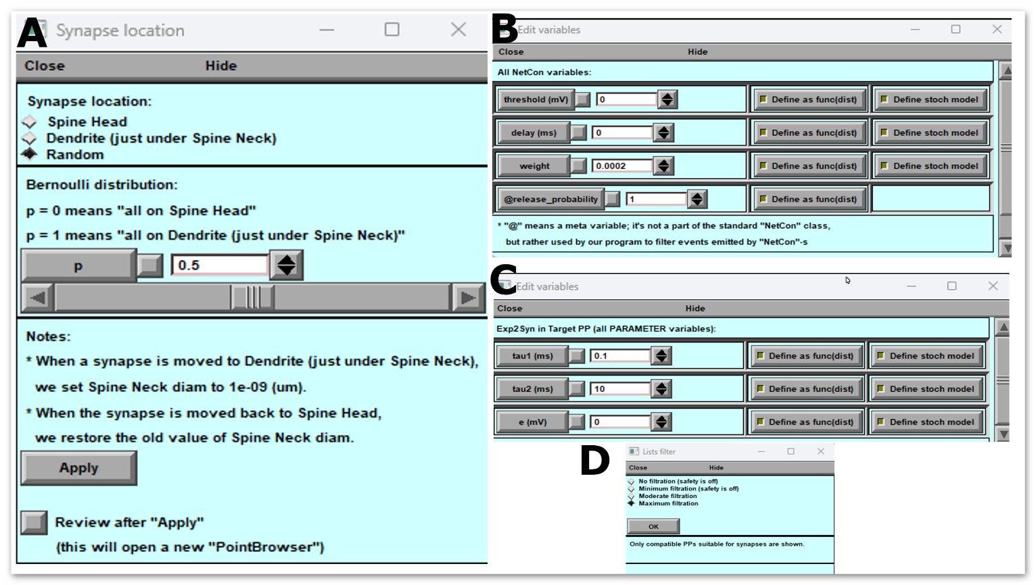

**Figure 18: Pop-Up Panels of Synaptic Manager. A) shows the manager of synaptic location, which allows users to visualize the spatial distribution of synapses. B) displays the manager of presynaptic signals, which provides information about the presynaptic neuron's activity. C) presents the manager of synaptic parameters, where users can modify synaptic properties such as strength and plasticity. D) shows the manager of presynaptic and postsynaptic mechanisms, located in the mechanism directory, which enables users to customize the synaptic transmission and reception mechanisms.**

This part guide you through this panel's upper and lower (**Fig.18A**) parts and help you understand their functionalities.

**Upper Part:** The upper part of the “**Synapse location**” panel enables you to modify the location of the synapses. There are three options available on this panel that you can use to change the location of synapses:

1. Place all synapses on spines
2. Place synapses on dendrites at the location of spines
3. Place synapses on dendrites and spines in different proportions

You can select any of the above options according to your requirements, and the software will make the necessary changes accordingly.

**Lower Part**: The lower part of the Synapse panel contains informational data and two buttons: "**Apply**" and "**Review after Apply**"

The informational data in the lower part provides details about the synapses' current location and density. It also shows the changes made to the synapse location after selecting any options mentioned in the upper part of the panel.

The " **Apply** " button confirms the changes made to the synapse location and saves them in the software. If you do not wish to save the changes, click the "Cancel" button.

The " **Review after Apply** " button lets you see how the program changed the synapse location. This option lets you verify the changes and ensure they align with your requirements.

### Synaptic structure.

#### Synaptic manager “top part” (**Figure 18 B**).

This part is for creating synaptic structures in the neuronal model **Figure 18. Synaptic panel (B)**. Synapses are two types in "**BrainCell**", one that requires a presynaptic signal and the other that works without a synaptic signal. The second type turns on depending on the "**onset**" parameter.

The panel (**Fig. 18**) offers two synaptic structures to accommodate these two types. The first structure includes presynaptic and postsynaptic mechanisms (**Source PP 🡪 NetCon 🡪 Target PP 🡪 Section**), while the second includes only postsynaptic mechanisms (**Source PP 🡪 Section**). Selecting one of these scenarios allows you to get either postsynaptic or presynaptic and postsynaptic mechanisms in the middle panel.

Please note that if you choose only postsynaptic mechanisms, you cannot use the "probability of release" parameter.

#### Synaptic manager “middle part”

This middle section of the panel (**Fig. 18 B**) has been specifically designed to allow you to organize and manipulate the presynaptic and postsynaptic functions of synapses, with a variety of parameters to choose from. Here, you can choose different presynaptic mechanisms (**left panel**) on the board and connect them to the synaptic mechanism (**right panel**). Once you have selected the appropriate presynaptic and postsynaptic mechanisms, you can start modifying the set of parameters just by clicking on the buttons labelled “**Edit source PP vars**”, “**Edit target PP vars**”.

The modification of the spatial distribution of Point base (**Synaptic**) mechanisms follows the same rules as the modification of the spatial distribution of standard density mechanisms, as explained in the section. Manage distribution mechanisms.

The randomness of synaptic parameters changes specifically when the presynaptic signal is generated, as opposed to the randomness of spatially distributed mechanisms. This means that stochastic events in the synapse only occur either when the presynaptic signal is generated or when the "onset" time parameter value is reached. However, the panel for controlling stochasticity is no different from the panel for spatial mechanisms Adjust the stochastic distribution of mechanisms..

#### Synaptic manager “bottom part”.

In order to manipulate the "[NetCon](https://www.neuron.yale.edu/neuron/static/py_doc/modelspec/programmatic/network/netcon.html)" mechanism, which connects the presynaptic and synapse functions via four parameters - "**threshold**", "**delay**", "**weight**", and "**release probability**" - we have designed a specific section at the bottom of the panel, featuring a button labeled "**Edit NetCon vars**" (Fig.B). This section is crucial to ensure seamless coordination between the presynaptic and postsynaptic functions.

In addition, you can use the "**Adjust list filter**" button (**Fig. 18**D) to select and add various synaptic mechanisms that are not yet included in the Middle panel. This feature allows you to add your own biophysical mechanism and use it to form new synaptic connections, unlike the standard synaptic mechanisms of “**Neuron**”. Please note that any new mechanisms should be uploaded to the "Mechanisms" section/directory.

To accept all modifications with synaptic connections, simply click the "**Apply**" button located in the same bottom section.

## Export cell model.



**Figure 19. Control Panel for Exporting Finished Cell Model.**

**The Control Panel for Exporting Finished Cell Models** is a crucial component of the **BrainCell**, providing users with a comprehensive set of options for exporting their completed cell models. This panel offers convenient access to various export functionalities, facilitating the seamless transition of cell models to external platforms or further analysis.

A) **Key to Call the Model Export Panel**: The Control Panel features a designated key that users can activate to open the Model Export Panel. This key is a quick and intuitive way to access the export functionalities.

B) **Pop-up Export Panel**: Upon activation, the Model Export Panel appears as a pop-up window, displaying a range of export options and settings. This intuitive interface allows Users to navigate and configure their desired export parameters conveniently.

## The Model Export Panel enables users to export the following components of their cell models:

***Cell Shape***: Users can export the intricate shape and morphology of the cell model, ensuring accurate representation and preservation of its structural details.

***Biophysical Mechanisms***: The panel allows users to export the biophysical mechanisms incorporated within the cell model. This property includes all developed details, encompassing spatial heterogeneity and stochastic properties, ensuring the faithful representation of the model's behaviour.

***Synapses***: Users can export the synapses in the cell model, capturing all relevant parameters and spatial-stochastic properties. This feature enables the retention of crucial synaptic properties during the export process.

***Hock File Export***: The panel provides an option to export the cell model as a hock file, facilitating compatibility with other software or platforms that support this format. This ensures seamless integration with external tools and analysis pipelines.

***Cluster Calculation and Parameter Selector***: For advanced users working with cluster computing, the panel offers a dedicated control panel for further calculations on the cluster. It also includes a parameter selector that can be automatically adjusted during cluster calculations, enhancing efficiency and flexibility.

***File Export for Biophysical Mechanisms***: The panel allows users to generate an F file specific to the biophysical mechanisms employed in the cell model. This file serves as a convenient reference and can be utilised for various analyses and simulations involving the biophysical properties of the model.

Users can easily export their cell models with the Control Panel for Exporting Finished Cell Models, preserving critical features such as cell shape, biophysical mechanisms, synapses, and more. This comprehensive export functionality empowers researchers to seamlessly collaborate, integrate, and analyze their cell models across different platforms and computational environments.

## Structure of export file.

B



A

**Figure 20. Form and Structure of the Export File. The panel displays warm messages (A) details about the format and arrangement of the export file (B).**

Whenever the user exports a cell model, a notification window (Fig.20) will warn them of any errors or inaccuracies that may have occurred during the exporting process. It is important to note that these errors are usually minor and do not impact the further utilization of the model. However, they serve as alerts for possible limitations within the model.

A successfully saved file in "hoc" - format will display inside as a commentary (Fig.20), a record of the mechanisms and their respective lines saved to the file. This valuable information facilitates the efficient utilization of the model's features in subsequent calculations or when modifying the model.

## BrainCell Software: Model Export - Parameter Selection

The model export feature in BrainCell serves two primary purposes: saving specific parameters and lengthy calculations without external graphics or additional features provided by the software package. However, to perform calculations effectively, it is essential to specify which parameters will change during the calculation process.

When the user clicks the "**Create File**" (Fig.21A) button, an additional window will open (Fig.21B), allowing them to define the parameters that will be saved. If the user selects the option to "Export Other Parameters," a new window will appear (Fig.21C) to facilitate this process. The window consists of two sections: a central panel for visualizing the selected parameters and a left panel with five buttons.

**Buttons in the Export Parameters Window:**

1. "**Add Biophys var**."

- This button enables the user to select a biophysics parameter from the pop-up window.

- Once selected, the chosen parameter will be displayed in the main window.

2. "**Add synapse var**."

- This button allows the user to select a synapse parameter from the pop-up window.

- Once selected, the chosen parameter will be displayed in the main window.

3. "**Add custom var**."

- This button is specifically designed for selecting a parameter created by the user, which may not be visible on the main Neuron panel.

- After selecting this option, the chosen parameter will appear in the main window.

4. "**Correct var**"

- This button enables the user to modify a specific parameter if necessary.

5. "**Delete var**"

- This button allows the user to remove a specific parameter from the selection.

Once the user has made their parameter selections, they can click "OK" to save these parameters in the parameter file. Subsequently, the user can perform further calculations while only modifying the saved parameters, streamlining the calculation process.

By utilizing the model export functionality and selecting the desired parameters, users can effectively save, modify, and perform calculations with ease in BrainCell.



**Figure 21. Exporting Control Parameters using Pop-up Windows**

**BrainCell allows users to define and export control parameters using pop-up windows. A. The first window saves specific parameters. B) second provides a selection interface for customizing the output file. C) third window gives an example of selecting soma diameter as a parameter. Users can easily create and export parameters for tailored simulations and analyses with these pop-up windows.**

## BrainCell Software: Exporting Computation Results

BrainCell allows users to export the results of their calculations by creating a "Result file" that contains specific variables of interest. This user manual section explains how to export and record these variables during the calculation process.

1. Creating the "**Runner.hoc**":

- Press the "Creating Runner.hoc" button to initiate the creation of the result file.

- This step prepares the system for recording and saving the desired variables.

2. Recording and Saving Variables:

- Press the "**Record and save some vars**" button, which opens a graph window.

- In the graph window, users can utilize the standard neuron function "**Print what**?" to select a set of variables they wish to record during the calculation.

- The selected variables will be saved to a file as a function of time, providing valuable data for further analysis.

3. Performing Calculations on a Parameter Grid:

- Utilize the "**Make a sweep for some vars**" button to perform calculations on a parameter grid.

- Unlike previous methods allowing only one input parameter, this functionality enables users to create a set of input parameters for automated calculations.

4. Configuring the Parameter Grid:

- A pop-up window will appear, allowing users to define the parameters of the grid.

- Set the initial and final values of the desired parameter and the step between them.

- Additionally, the pop-up window allows choosing between a linear or non-linear grid configuration.

Following these steps, users can export computation results by creating a "Result file" with specific variables of interest. The graph window facilitates the selection and recording of variables, while the parameter grid functionality enables automated calculations on a range of input parameters. This comprehensive approach enhances analysis capabilities and allows a more comprehensive exploration of model behaviour.

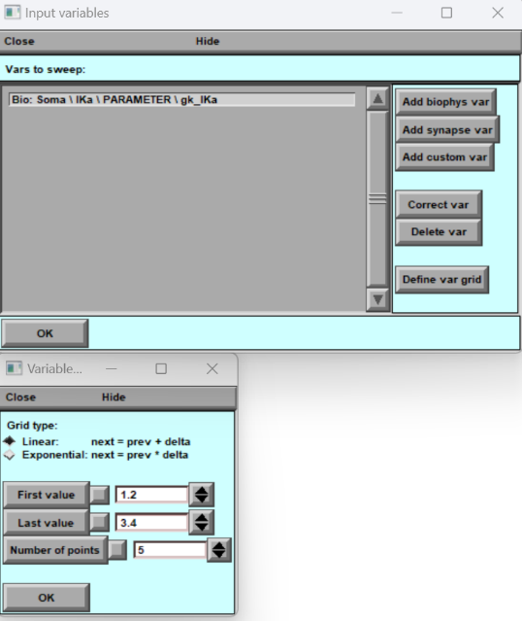



**Figure 22. Exporting of control of computation Pop-up Windows**

**BrainCell allows users to define and export the control of computation pop-up windows. A. The first window saves specific parameters. B) second provides a plot for customizing the output file. C) third window gives an example of selecting somatic gpas as variable that will be in the result file D) window gives an example of selecting soma gk as a parameter. F) the window for the grid definition.**

## Simulation modes: Users can choose from a variety of simulation modes to simulate